# Exercise - Deploy SharePoint Framework solutions to tenant App Catalog

In this exercise, you'll create a SharePoint Framework (SPFx) client-side web part that will be used to try different deployment configurations.

## Create a deployment package for the project

When NPM completes downloading all dependencies, build the project by running the following command on the command line from the root of the project:

gulp build

Next, create a production bundle of the project by running the following command on the command line from the root of the project:

gulp bundle --ship

Finally, create a deployment package of the project by running the following command on the command line from the root of the project:

gulp package-solution --ship

## Deploy the package to a SharePoint site

In a browser, navigate to your SharePoint tenant's App Catalog site.

Select the **Apps for SharePoint** link in the left-hand navigation.

Drag the package created in the previous steps, located in the project's **./sharepoint/solution/deployment-demo.sppkg**, into the **Apps for SharePoint** library.

SharePoint will launch a dialog asking if you want to trust the package:

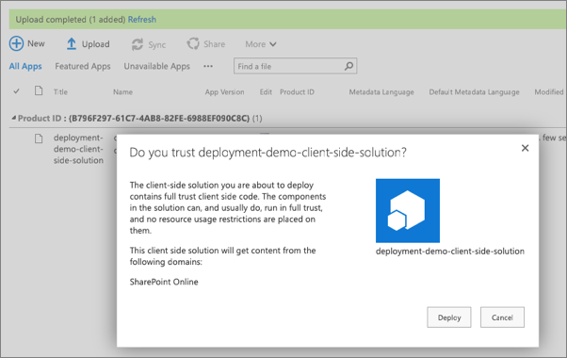

Select **Deploy**.

## Install the SharePoint package in a site collection

Navigate to an existing site collection, or create a new one.

Select **Site Contents** from the left-hand navigation.

From the **New** menu, select **App**.

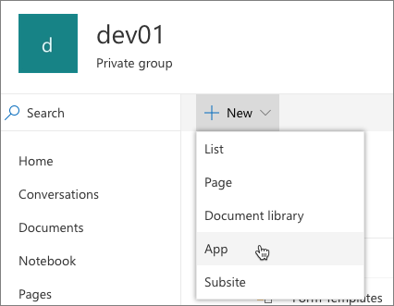

Locate the solution you previously deployed and select it.

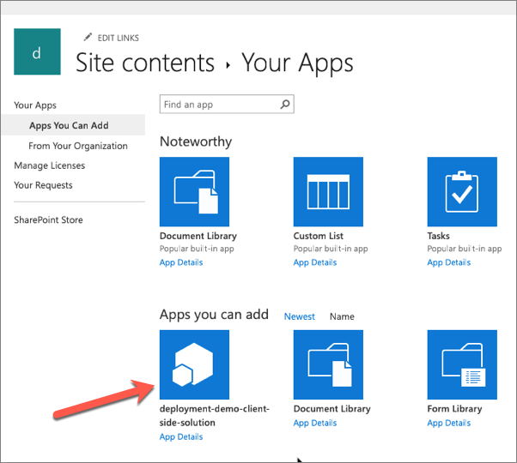

SharePoint will start to install the application. At first it will be grayed out, but after a few moments you should see it listed as in the following screen capture:

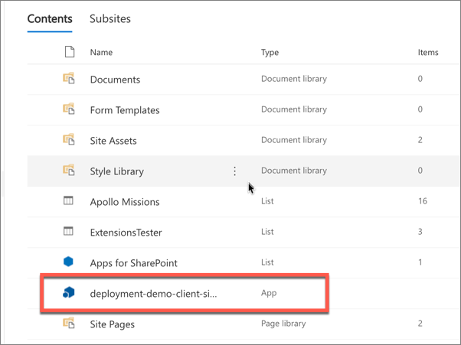

## Add the web part to a page

Navigate to a SharePoint page.

Put it in edit mode by selecting the **Edit** button in the top-right portion of the content area on the page.

Select the web part icon button to open the list of available web parts:

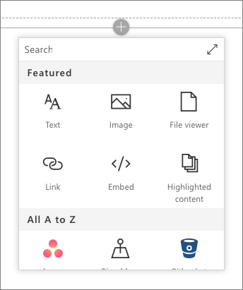

Select the expand icon, a diagonal line with two arrows in the top-right corner, to expand the web part toolbox.

Scroll to the bottom, locate, and select the **Deployment Demo** web part.

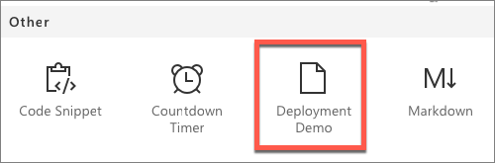

## Examine the deployed web part files

Once the page loads, open the browser's developer tools and navigate to the **Sources** tab.

Refresh the page and examine where the JavaScript bundle is being hosted.

If you have not enabled the Office 365 CDN, then the bundle will be hosted from a document library named **ClientSideAssets** in the App Catalog site.

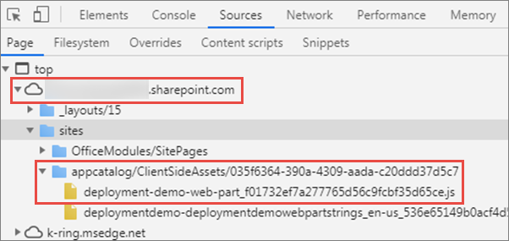

If you have enabled the Office 365 CDN, then the bundle will be automatically hosted from the CDN.

